VALUATION REPORT OF

Mr. Nilesh N. Borade & Mr. Siddhesh N. Borade
(Proposed Purchaser)

At

Residential Flat No. 403, 4th Floor, Building No. 2, Sapphire Tower, Regency Tower, Opp. Horizon School, Kavesar, G.B Road, Thane (W)- 400615.

CANARA BANK-TALAO PALI-THANE BRANCH
VALUATION REPORT (IN RESPECT OF FLAT)

Ref.: UCVLLP/CANARA/9610 Date: 16/01/2026

I | GENERAL
1. | Purpose for which the valuation is made | :
2. | a) Date of Inspection | :
 | b) Date on which the valuation is made | :
3. | Name of the owner (s) and his/ their address(es) with Phone No. (Details of share of each owner in case of joint ownership). | :
4. | List of documents produced for perusal | :
5. | Brief Description of the property | : | Property Add.:  Landmark:  Building Details:  Property Details:  Amenities:  Landholding Type:
6 | Location of the property
 | a) Plot No./ Survey No. | :
 | b) Door No./ Property No. | :
 | c) T. S. No/Village | :
 | d) Ward/ Taluka | :
 | e) Mandal/District | :
7. | Postal address of the property | :
8. | City/ Town | :
 | Residential Area | :
 | Commercial Area | :
 | Industrial Area | :
9. | Classification of Area | :
 | i) High/ Middle/ Poor | :
 | ii) Urban/ Semi-Urban/ Rural | :
10 | Coming under Corporation limit/ Village Panchayat/Municipality. | :
11 | Whether covered under any State/ Central Govt. enactments (e.g. Urban Land Ceiling Act) or notified under agency area/ scheduled area/cantonment area. | :
12. | Boundaries of the property | : | As per Agreement | As per Actual
 | North | :
 | South | :
 | East | :
 | West | :
13 | Dimensions of the site | : | A  (As per Agreement) | B  (Actuals)
14 | Extent of the site | :
14.1 | Latitude, Longitude & Co-ordinates of flat | :
15. | Extent of the site considered for Valuation | :
16. | Whether occupied by the owner/ tenant? If occupied by tenant since how long? Rent received per month. | :
11 | APARTMENT BUILDING
1. | Nature of the Apartment | :
2. | Flat No. & Floor | :
3. | Name of the Apartment | :
4. | Postal Address | :
5. | Location | :
 | T. S. No. | :
 | Block No. | :
 | Ward No. | :
 | Village/Municipality/Corporation | :
 | Door No. Street or Road (Pin Code) | :
6. | Description of the Locality Residential/ Commercial/Mixed. | :
7. | Year of Construction | :
8. | Number of floors | :
9. | Type of structure | :
10 | Number of Dwelling Units in the Building. | :
11 | Quality of Construction | :
12 | Appearance of the Building | :
13 | Maintenance of the Building | :
14 | Facilities available. | :
 | Lift | :
 | Protected Water Supply | :
 | Underground Sewerage | :
 | Car Parking—Open/ Covered | :
 | Is Compound wall existing? | :
 | Is pavement laid around the Building? | :
III. | FLAT/GALA
1. | The floor in which the property is situated | :
2. | Door No. of the property | :
3. | Specifications of the property | :
 | Roof | :
 | Flooring | :
 | Doors | :
 | Windows | :
 | Fittings | :
 | Finishing | :
4. | House Tax | :
 | Assessment No. | :
 | Tax paid in the name of | :
 | Tax amount | :
5. | Electricity Service Connection No. | :
 | Meter Card is in the name of | :
6. | How is the maintenance of the property? | :
7. | Deed executed in the name of | :
8. | What is the undivided area of land as per Sale Deed? | :
9. | What is the plinth area of the property? | :
10 | What is the Floor Space Index (Approx.). | :
11 | What is the Carpet area of the property? | :
12 | Is it Posh/ I Class/ Medium/ Ordinary? | :
13 | Is it being used for Residential/ Commercial/Industrial purpose? | :
14 | Is it owner occupied or let out? | :

PART C - VALUATION OF EXISTING PROPERTY

IV | MARKETABILITY
1. | How is the marketability? | :
2. | What are the factors favouring for an extra Potential Value? | :
3. | Any negative factors are observed which affect the market value in general? | :
V | RATE
1. | After Analysing the comparable sale instances, what is the composite rate for a similar property with same specifications in the adjoining locality? | :
2. | Assuming it is a new construction, what is the adopted basic composite rate of the property under valuation after comparing with the specifications and other factors with the property under comparison (given details). | :
3. | Break-up for the Rate:
 | i) Building + Services | :
 | ii) Land + Others | :
4. | Guideline rate obtained from the Registrar’s Office (an evidence thereof to be enclosed). | :

VI. | COMPOSITE RATE ADOPTED:
a. | Depreciated Building Rate
 | Replacement cost of property with Services[v(3)i] | :
 | Age of building | :
 | Life of the Building estimated | :
 | Depreciation percentage assuming the salvage value as | :
 | Depreciated Ratio of the Building | :
b. | Total Composite Rate arrived for valuation. | : | --
 | Depreciated Building Rate VI(a) | :
 | Rate of Land and Other V(3)ii | :
 | Total Composite Rate | :

DETAILS OF VALUATION
Sr.  No. | Description | Carpet Area (sq.ft.) | Rate per sq.ft. (Rs.) | Estimated Value (Rs.)
- 1 | Value of the Flat | 800 | 19,500/- | 1,56,00,000/-
- 2 | Car Parking | 1 no. | 8,00,000/- | 8,00,000/-
- 3 | Interior Decorations | ---- | ---- | Nil
- 4 | Others ( Government Charges) | ---- | ---- | Nil
 | Total Rs. |  |  | 1,64,00,000/-
 | Say Rs. |  |  | 1,64,00,000/-

(Valuation: Here, the approved valuer should discuss in details his approach to valuation of property and indicate how the value has been arrived at, supported by necessary calculation. Also, such aspects as impending threat of acquisition by government for road widening/public service purposes, sub merging & applicability of CRZ provisions (Distance from sea-coast/tidal level must be incorporated) and their effect on i) salability ii) likely rental value in future and iii) any likely income it may generate may be discussed)

As a result of my appraisal and analysis, it is my considered opinion that the present fair market value of the above property in the prevailing condition with aforesaid specifications is Rs. 1,64,00,000/- (Rs. One Crore Sixty Four Lakh Only).

The Realizable Value (90%) of the flat is Rs. 1,47,60,000/- (Rs. One Crore Forty Seven Lakh Sixty Thousand Only).

The Distress Value (80%) of the flat is Rs. 1,31,20,000/- (Rs. One Crore Thirty One Lakh Twenty Thousand only)

The Government value of the is Rs. 1,21,56,480/- (Rs. One Crore Twenty One Lakh Fifty Six Thousand Four Hundred Eighty Only)

Rental Value of the flat is Rs. 34,000/- (Rs. Thirty Four Thousand Only).

Place: Thane Manoj Kumar Sharma
Date: 16/01/2026

Govt. Valuer & Chartered Engineer
Panel Valuer of Canara Bank
(IBBI/RV/07/2019/11044)
The undersigned has inspected the property detailed in the Valuation Report dtd. 16/01/2026. We are satisfied that the fair and reasonable market value of the property is Rs. 1,64,00,000/- (Rs. One Crore Sixty Four Lakh Only).
Signature
(Name of the Branch Manager with Office Seal)
Disclaimer, Notes and Limitation:
- We have finalized the report on the basis of site visit and copy of: Draft Agreement, Old Agreement for sale/Index-II, C.C., Share certificate, etc. However, we have not been provided with latest registered agreement for sale/Index-II, floor plan, O.C, title report, Approved Plan, etc. for verification purpose.
- The said property was vacant at the time of inspection.
- Flat number and name of the seller was displayed on society name board.
- Property is situated in residential area.
- The property is inspected as shown by Mr. Nilesh Borade along with banker Mr. Abhishek Dubey.
- We consider the area given in the Draft agreement, declared by the party and submitted for registration with the government authorities as final for valuation purpose. Any area that is not stated in the Draft agreement is not considered for valuation unless the area is measured by us in which case that may be considered for valuation purpose.
- The scope of our valuation work is only for banks financial/loan purpose. Further, please be noted that this report shall not be used for any litigation purpose.
- Encumbrance of Loan, Government and other dues, stamp duty, registration charges, transfer charges etc, if any are not considered in the valuation. We assumed that the assets are free from encumbrance unless otherwise stated to us by the party in writing.
- The value given in our report is the estimate of the Fair Market value of the property as on date, considering various aspects of the property as mentioned above.
- The value given in our report is the estimate of the Fair Market value of the property as on date, considering various aspects of the property like amenities in projects, locational advantages, demand and supply equation, interior designing done in the property, outside view, Vashtu aspects etc. which is generally more than the Government ready reckoner value.

PART D – CERTIFICATE
- It is hereby certified that in my opinion
The present stage value of the property which is fully completed is Rs. 1,64,00,000/-
- The present market value of the property by adopting suitable composite rate is Rs. 1,64,00,000/- (Rs. One Crore Sixty Four Lakh Only).
- The forced sale value of the property is estimated as 20% less than the present market value
- The Realizable value of the property is estimated as 10% less than the present market value
- Number of title deed(s) involved in this property is ---. The relevant document for the subject flat in the opinion of this valuer is the deed dated with Registration Number ----- registered in the ---- Registrar’s Office ----
- If this property is offered as security, the concerned financial institution is requested to verify the extent of undivided share of land mentioned this valuation report with respect to the latest legal opinion.
- Value varies with the purpose and date of valuation. This report is not to be referred if the purpose is different other than mentioned in I (1).
- The property was inspected on 14/01/2026 by our Engineer, Mr. Kaushik in the presence of Mr. Nilesh Borade along with banker Mr. Abhishek Dubey.
- The legal aspects were not considered in this valuation.
- This valuation work is undertaken by the valuer based upon the request from bank.

Place: Thane
Dated: 16/01/2026
Manoj Kumar Sharma

Govt. Valuer & Chartered Engineer
Panel Valuer of Canara Bank
(IBBI/RV/07/2019/11044)

PHOTOGRAPHS OF PROPERTY

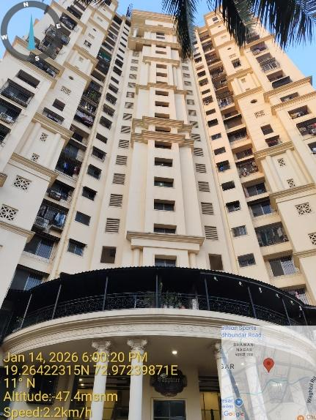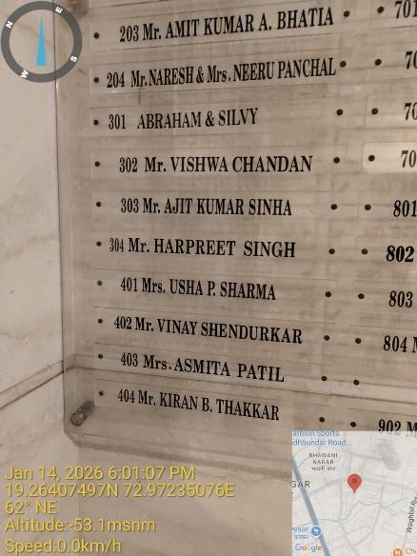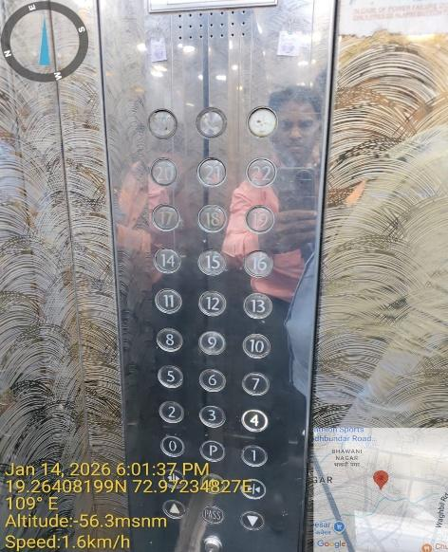

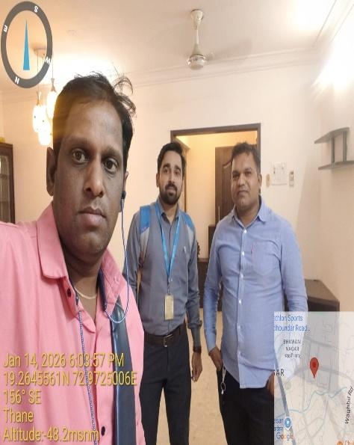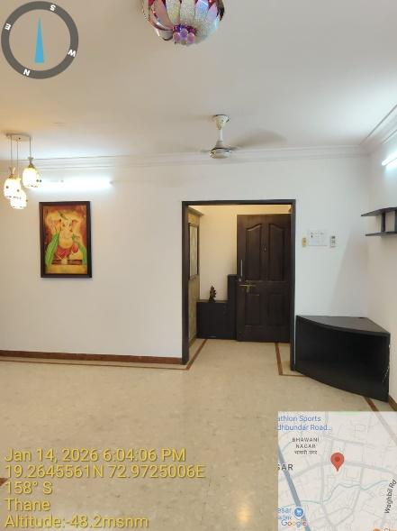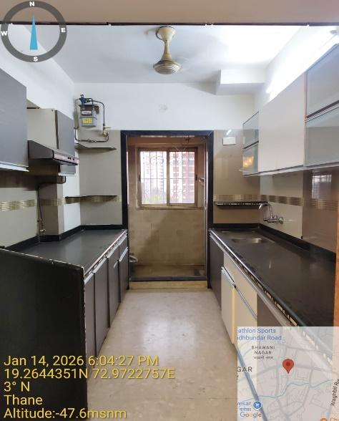

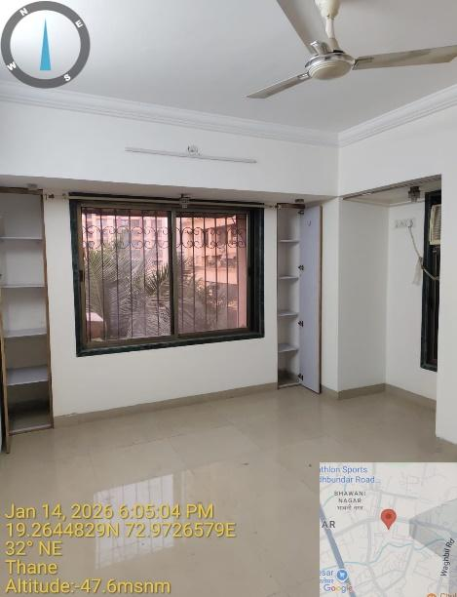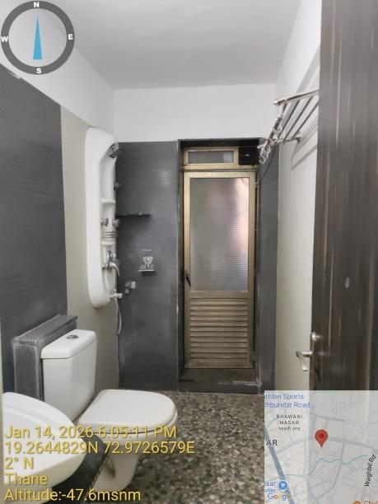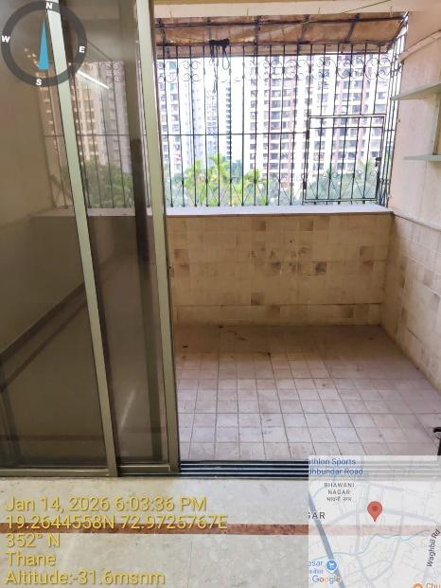

Location Map

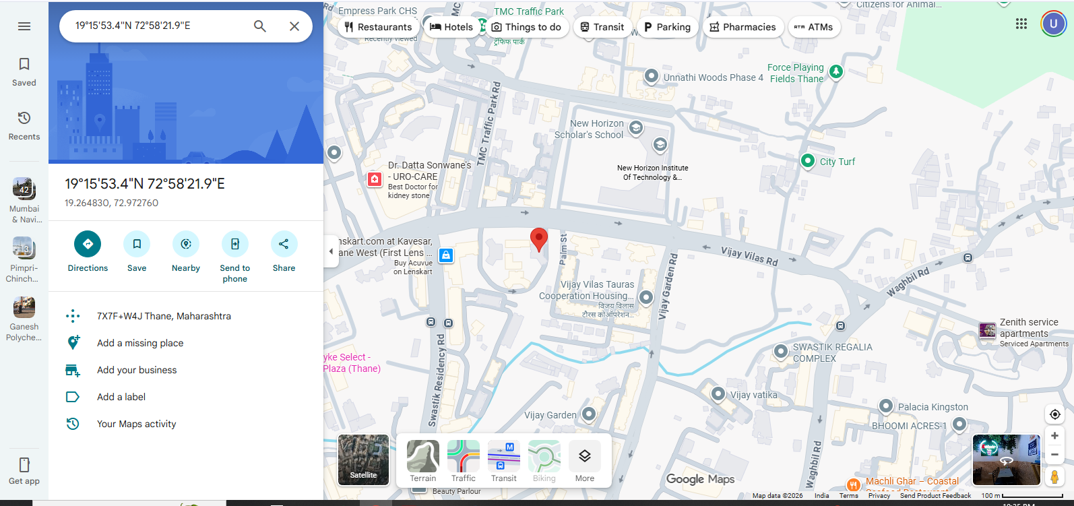

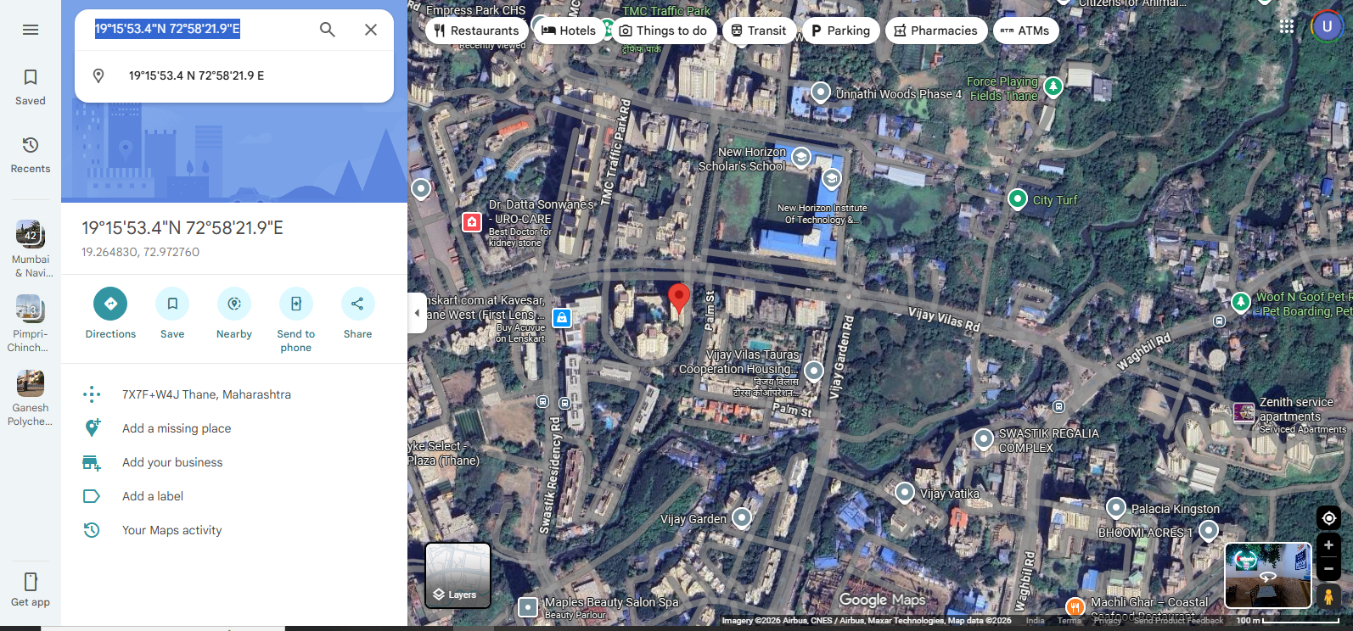

Government Ready Reckoner rate 2025-26

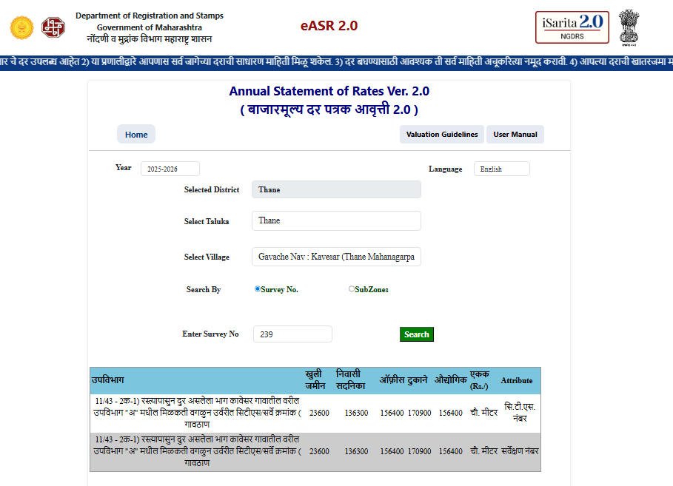

Sale Transaction

